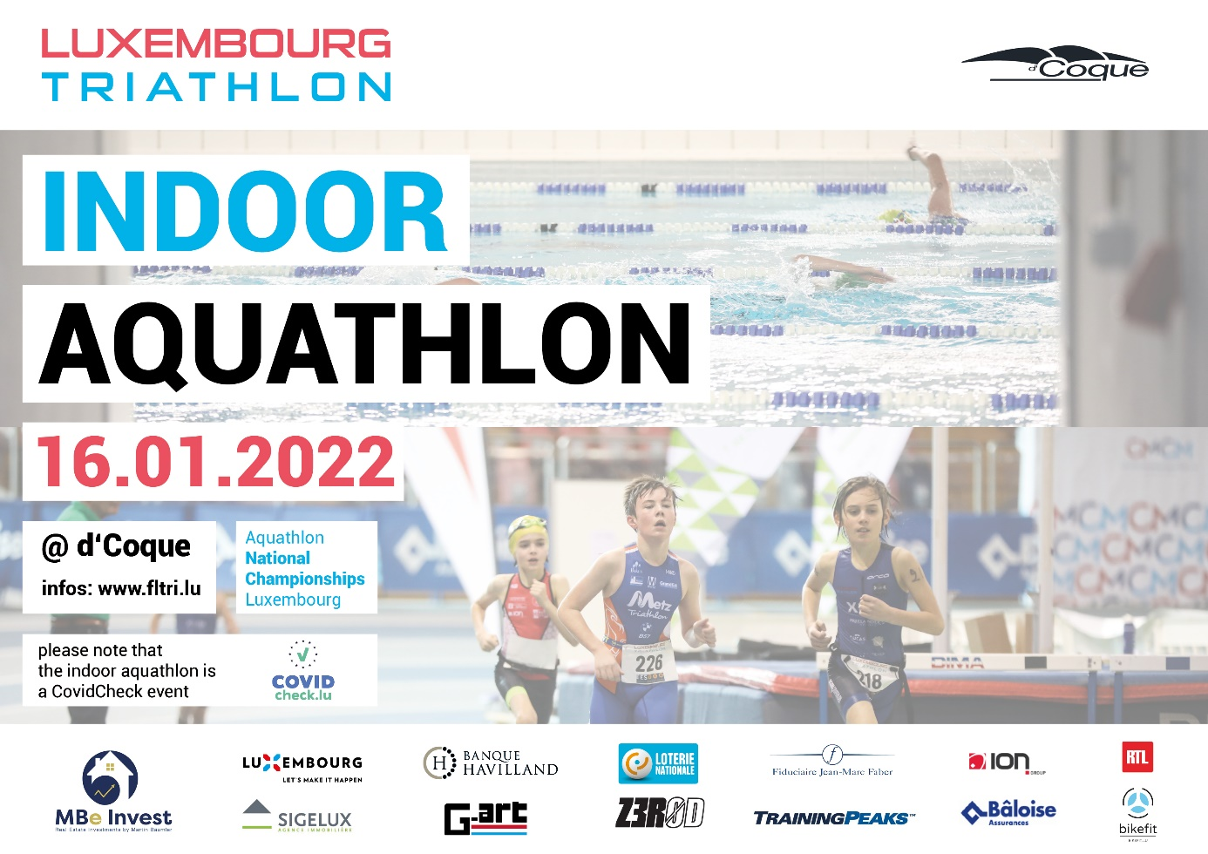

|  |  |
| --- | --- |
| **Fédération Luxembourgeoise de Triathlon a.s.b.l.** | **9th EES FLTRI Indoor Aquathlon** |
| **ATHLETE'S GUIDE** |

Table of contents

1 Organisation 1

2 Definition of the competition 1

3 Terms and conditions 2

4 Eligibility for registration 2

5 Classification and qualification criteria 2

6 Schedule 3

7 Warm-up and start procedure 3

8 False start 3

9 Race format and categories 4

10 National championship

11 COVID procedures

Appendix A: Pool illustration 6

Appendix B: Arena illustration 7

Appendix C: Event Timing 7

# Organisation

The « Indoor Aquathlon » is a competition organised by the Fédération Luxembourgeoise de Triathlon asbl FLTRI).

Phone: +352 26 44 14 94

Mail: [info@fltri.lu](mailto:info@fltri.lu)

Web: [www.fltri.lu](http://www.fltri.lu)

**The competition takes place at the Arena of the „Coque" Sports Center (**[**www.coque.lu**](http://www.coque.lu)**).**

**Address: 2, rue Léon Hengen L-1745 Luxembourg**

# Definition of the competition

The « Indoor Aquathlon » is a competition consisting of a swim followed by a run. World Triathlon Competition Rules are applied. An illustration of the pool is given in the appendix.

* **Before the race**:
* Body marking of the bib number has to be made on each arm at the registration.
* Athletes have to register for each series separately at the check-in zone 20min before each of their race starts. The check-in zone is in arena entrance marked by a panel. **No athlete is allowed to go to the pool on his own!** To avoid any accidents, crossing or blocking of athletes between the pool and the transition during their race, the referee in charge of the check-in zone will bring the group of athletes (of the same series) to the pool as soon as the swim of the previous race is done. This is also to avoid wrong signals of the timing chips. **Disrespecting this procedure can lead to a time penalty or DSQ.**
* **A mandatory briefing is given at the briefing zone.**
* The **swim**: pool length of 50m and 6 lanes.
* Wearing a swim cap is mandatory for all athletes.
  + Start side:
    - Age Grouper, Junior, Youth A/B (250m) will start on side B of the pool.
    - Kids A/B (50m) will start on side B of the pool.
    - Youth C (100m) will start on side A of the pool.
  + Lane attribution:
    - For all races except Kids A/B: 2 or 3 athletes per lane.
    - Series men and women: starting position will be attributed by the starter by drawing
    - Quarterfinal, semi-final and final men and women: starting position will be attributed depending of the previous race ranking
* The **transition**:
  + **ONLY athletes are allowed to enter the transition zone!**
  + After the swim all items of the athlete have to be put into the transition bag. No item has to be left at the transition! The bag has to be put down in the drop-off zone at the beginning of the run. Failure to comply with this rule will result in a 10 second time penalty.
  + The use of the official transition bag, given at the registration, is mandatory for all athletes, except Kids A/B! The transition bags can be picked up at the pick-up one immediately after each race. Athletes have to show their bib number to get their bag. **30 minutes after the finish of the last race, the pick-up zone will be closed.**
* The **run**: 200m from the pool to the arena and around the indoor track of 200m:
  + The run from the pool exit to the 1st crossing of the finish line (including transition zone) is counted as 200m.
  + Each lap on the indoor track will count as 200m.
  + Wearing shoes is mandatory for Kids A/B and Youth C athletes.
  + Wearing the bib number on the front side after the transition bag drop off zone is mandatory.

# Terms and conditions

By enrolling in the competition, every athlete pledges to adhere to the regulations and discharges the organizer of any incident or accident that may occur due to disregarding these regulations.

A valid license is mandatory for participating in the event. The FLTRI will sell daily licenses on site to athletes that don’t have or cannot show a valid triathlon license at the race registration.

# Eligibility for registration

The competition is open for male and female athletes born in 2012 or earlier. Age Group, Junior and Youth A/B athletes will compete against each other.

The number of participants is limited to 216 for elite races.

144 men — 72 women

Registration has to be done at least on Thursday January the 13th at midnight

# Classification and qualification criteria

The number of series will depend on the number of registrations.

## Age Group — Junior — Youth A/B: Men

* 8 series; qualification to the next round of the 3 best athletes of each series (24) + the 10 best competition times (10) + 3 best athletes of each "2nd round" (12) + 2 best times (2) for a total of 48 qualifiers to the ¼-finals.
* Qualification of the 4 best athletes of each ¼-final (16) + the 8 best competition times for a total of 24 qualifiers for the ½-finals.
* Qualification of the 4 best athletes of each ½-final (8) + the 4 best competition times for a total of 12 qualifiers for the final.

## Age Group — Junior — Youth A/B: Women

* 4 series; qualification to the next round of the 3 best athletes of each series (12) + the 7 best competition times + the 2 best athletes of each "2nd round" (4) + the best time (1) for a total of 24 qualifiers to the ½-finals.
* Qualification of the 4 best athletes of each ½-final (8) + the 4 best competition times for a total of 12 qualifiers for the final.

## Youth C

* There will be a 1st final with the 24 best athletes (mix of boys and girls) and a 2nd final with the remaining athletes.
* Final classification by addition of the 2 races (series + finals).

## Kids A/B

* There will be a 1st final with the 24 best athletes (mix of boys and girls) and a 2nd final with the remaining athletes.
* Final classification per category (Kids A and Kids B) by addition of the 2 races (series + finals).

# Schedule

Registration and bib number pick-up starts at 8:30

Race schedule will be confirmed after the registration closes on [www.fltri.lu](http://www.fltri.lu) and Facebook: Luxembourg Triathlon

# Warm-up and start procedure

Warm-up only allowed for Age Group — Junior — Youth A/B races (250m):

* after the athletes’ lanes have attributed, athletes can enter the pool on side A,
* once all the athletes have entered the pool, a technical official (TO1) walks from side A to side B; during warm-up the athletes must remain between TO1 and side B of the pool and move towards side B as the TO1 moves forward to side B,
* a second technical official (TO2) will enter the pool area on side A as soon as the race-start has been cleared,
* when ready, TO1 will call the "on your mark" signal, requiring the athletes to put one hand on the pool wall,
* start signal is given by whistle blow of TO2 on side A of the pool.

# False start

As per World Triathlon competition rules, a false start of few athletes will result in a 10 seconds time penalty or in a new start in the case of a false start from several athletes.

# Race format and categories

|  |  |  |  |
| --- | --- | --- | --- |
| **Category** | **Swim distance** | **Run distance** | **Competition format** |
| Kids B (2013-2014) Kids A (2011-20012) | 50m | 400m | Series A Series B Final A Final B  Classification by addition of the 2 race times |
| Youth C (2009-2010) | 100m | 600m | Series A Series B Final A Final B  Classification by addition of the 2 race times |
| AG — Junior — Youth A — Youth B Men (2008 and earlier) | 250m | 1000m | Series  2nd round: "rattrapage"  1/4 Finals 1/2 Finals Final |
| AG — Junior — Youth A — Youth B Women (2008 and earlier) | 250m | 1000m | Series  2nd round: "rattrapage" 1/2 Finals Final |

# National championships

In the case that the race is declared as a national championship, the national championship will be organised starting with the Youth C category and upwards.

For the ranking of the championship, the results will be considered like this (from YB and upwards):

* The ranking of the final
* The ranking of the ½ Finals (the time for the place)
* The ranking of the ¼ Finals (the time for the place)
* The ranking of the rattrapages

Youth C championship: classification by addition of the 2 races (series + finals).

Athletes racing for the national championships must wear their club uniform during the final. The club uniform will be controlled at the check-in zone before the final.

# COVID regulations

The event will take place under the CovidCheck regime

Each spectator or participant older than 12 years and 2 months has to present a valid QR code under the "2G+" regime

This means that one has to fulfill one of the 3 conditions below:

* be in possession of a valid vaccination certificate and a negative PCR or certified rapid antigen result or perform a self-diagnostic test for SARS-CoV-2 on site,
* be in possession of a valid recovery certificate and a negative PCR or certified rapid antigen result or perform a self-diagnostic test for SARS-CoV-2 on site,
* present a medical exemption form, validated by the "Directeur de la Santé" + negative PCR or certified rapid antigen result or perform a self-diagnostic test for SARS-CoV-2 on site

## Exceptions

1. Participants and referees under the age of 19 may attend under the "3G" regime and present a valid QR code under the "3G" mode. This means that one has to fulfill one of the conditions below:

* be in possession of a valid vaccination certificate,
* be in possession of a valid recovery certificate
* present a negative PCR test (<48 hours) or a negative certified rapid antigen test result (<24 hours)

1. A person having received their booster vaccination is exempt from having to present a negative PCR or a certified rapid antigen test or having to perform a test on site.

## Additional information:

A certificate may only be validated through the official Covid19.lu app via a QR code. Each person wanting to enter the event area is required to present an ID with photograph during the Covid check procedure.

If a person refuses or is unable to present a certificate or being unable to justify their identity, they cannot attend the event.

# Appendix A: Pool illustration



# 

# Appendix B: Arena illustration

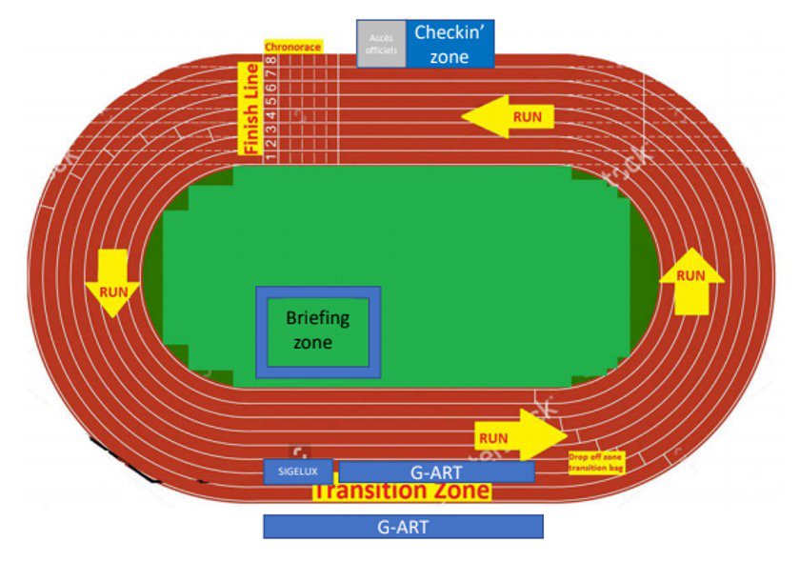

**Appendix C: Event Timing**

|  |  |  |
| --- | --- | --- |
| **HORAIRES** | | |
| **Check-in time** | **Start time** |  |
|  | 08:30 | **Retrait des dossards** |
| 09 :46 | 10:00 | Serie 1 hommes |
| 09 :57 | 10:11 | Serie 2 hommes |
| 10 :08 | 10:22 | Serie 3 hommes |
| 10 :19 | 10:33 | Serie 4 hommes |
| 10 :30 | 10:44 | Serie 5 hommes |
| 10 :41 | 10:55 | Serie 6 hommes |
| 10 :52 | 11:06 | Serie 7 hommes |
| 11 :03 | 11:17 | Serie 8 hommes |
| 11 :14 | 11:28 | Serie 1 femmes |
| 11 :25 | 11:39 | Serie 2 femmes |
| 11 :36 | 11:50 | Serie 3 femmes |
| 11 :47 | 12:01 | Serie 4 femmes |
| 12 :00 | 12:12 | Kids A garçons |
| 12 :06 | 12:18 | Kids A filles |
| 12 :12 | 12:24 | Kids B garçons |
| 12 :18 | 12:30 | Kids B filles |
| 12 :24 | 12:36 | Serie 1 youth C filles |
| 12 :33 | 12:45 | Serie 2 youth C filles |
| 12 :42 | 12:54 | Serie 1 youth C garçons |
| 12 :51 | 13:03 | Serie 2 youth C garçons |
| 12 :58 | 13:12 | **2ème tour hommes 1** |
| 13 :09 | 13:23 | **2ème tour hommes 2** |
| 13 :20 | 13:34 | **2ème tour hommes 3** |
| 13 :31 | 13:45 | **2ème tour hommes 4** |
| 13 :42 | 13:56 | **2ème tour femmes 1** |
| 13 :53 | 14 :07 | **2ème tour femmes 2** |
| 14 :11 | 14:25 | ¼ finale 1 hommes |
| 14 :22 | 14:36 | ¼ finale 2 hommes |
| 14 :33 | 14:47 | ¼ finale 3 hommes |
| 14 :44 | 14:58 | ¼ finale 4 hommes |
| 14 :55 | 15:09 | 1/2 finale 1 femme |
| 15 :06 | 15:20 | 1/2 finale 2 femme |
| 15 :21 | 15:31 | Finale 1 kids A |
| 15 :27 | 15:37 | Finale 2 kids A |
| 15 :33 | 15:43 | Finale 1 kids B |
| 15 :39 | 15:49 | Finale 2 kids B |
| 16 :10 | 16:20 | 1/2 finale 1 homme |
| 16 :15 | 16:30 | 1/2 finale 2 homme |
| 16 :28 | 16:40 | Finale 1 youth C |
| 16 :38 | 16:50 | Finale 2 youth C |
|  | 17:10 | **PODIUM tournoi Kids et Youth C + championnat YC** |
| 17 :20 | 17:40 | Finale femmes |
| 17 :50 | 18 :10 | Finale hommes |
|  | 18:20 | **PODIUM championnat national scratch** |
|  | 18:25 | **PODIUM tournoi scratch (YB/YA/juniors/ élite)** |